Bank and Atm
System database

by

Chinnapat Wongplub Jad Younes
1610030001 2010210026

Beya Muli Tshita Olivier Priyadarshini Kafle
1907060023 1910050002

Course Instructor: Ajarn Atikom Srivallop
Department: Information Technology

June, 2021

INDEX PAGE

Cover Page 1
Index Page 2
Ch1: Introduction 3
Ch2: Requirement 4
Ch3: Diagram 5
Ch4: Queries 6-7
Ch5: Discussion & Conclusion 7

INTRODUCTION

First, in our ATM system, we have provided the option to withdraw, transfer, deposit, and view balance. Base on ER diagram we have 6 entities that linked with M: N and 1: 1 relationship. To explain briefly, we use the Info-customer table as the information, and like with the Account table, so is separate and easy to find the account. Next, the ATM table is the same as a real ATM that place in somewhere, which has we linked to each transaction with M: N relationship. So, the data of ATM and information of the customer will be recorded in another table that has all foreign key in the table, it was very useful for employees to find the data where the data is from the location. We also create a program that can be working with database ATM, we are designing this as a concept of Miniworld that can be used in real life and we are testing the software and database which can be operated together.

REQUIREMENTS

For the requirements we used 5 different program and 1 website to make our project done.

- MySQL: It is our main program where everything started and ended at the same time. At the first place, we used MYSQL to create our ER diagram and located all the needed entities for a complete ATM Database.

- IntelliJ IDEA: Its a programming program we used to write the code using Java Language.

- Microsoft PowerPoint: We used the program to create our presentation for the final exam where we explained everything about our ATM Database project.

- Microsoft Word: this program was used to write and finish our report about the ATM Database project, where it covers the introduction, Requirements, Diagram, Queries, Discussion & Conclusion.

- Snipping tool: This program majored to take screenshots of our code and then uploading them into our PowerPoint presentation to explain them well and clearly.
As well as we used draw.io website to work more on our diagram.

DIAGRAM

We have 2 diagram which is ER-Diagram, UML Diagram, as you can see, ER-Diagram has 6 entity and 3 table that store foreign key.
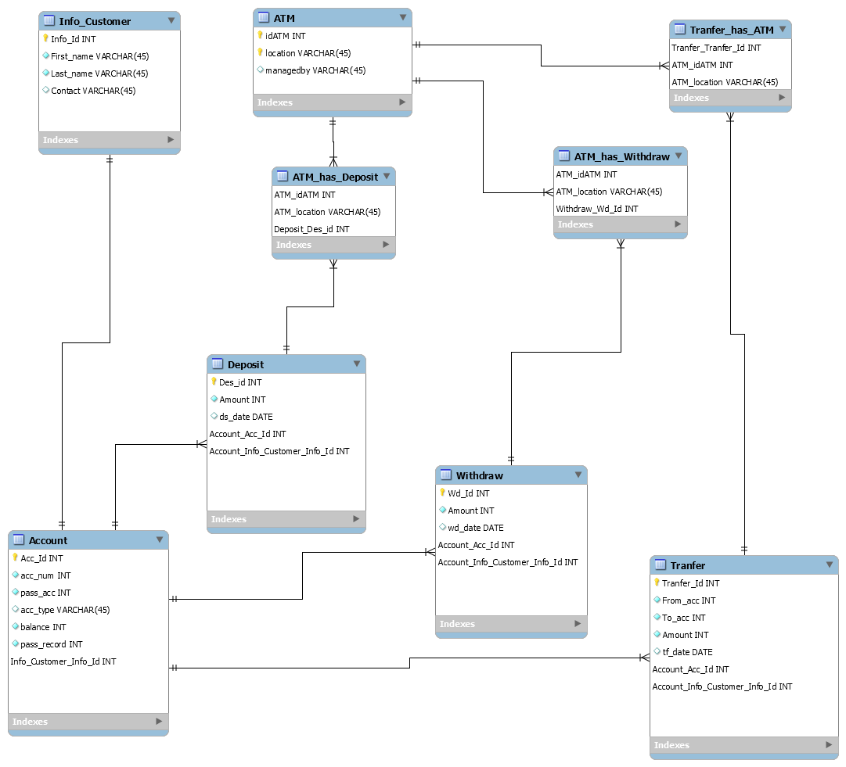

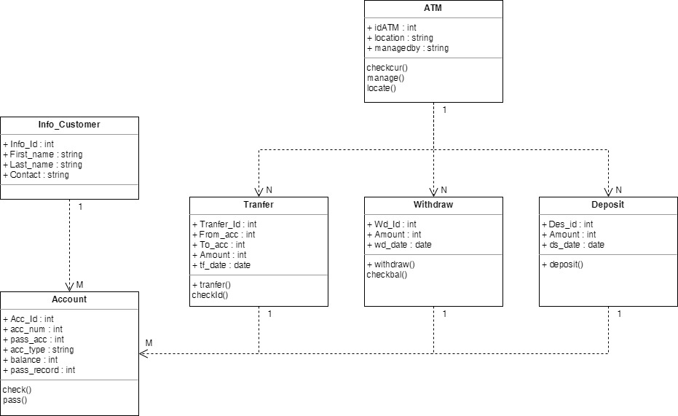

QUERIES

Select query is one that retrieves data from a database whereas an action query asks for additional operations on data, for example: insertion, updating, deleting or other forms of data manipulation. The tasks such as withdrawing any amount, depositing the cash, process of withdrawing the money from the ATM after putting in our ATM card, entering the pin number are all transactions after these transactions take place it changes the contents of a database.

Automated Teller Machines (ATMs) are an important part of the finance and banking system. ATMs are used to perform various transactions and account related functionalities at bank. The ATM system can be represented as object-oriented model to show the flow of data within the system, such as following.

- Entity and Attributes:
• The first entity we have is ATM with the primary key ‘idATM INT’ (INT NOT NULL) and primary key location (VAR) that stores Managed by (VAR).

• The second entity is Info_Customer with primary key 'Info_Id INT' (INT NOT NULL) and other attributes that store customer's information which are FirstName (VAR), LastName (VAR), contact (INT).

• The third entity is Deposit with the primary key 'Des_id’(INT NOT NULL) and other attributes which are Amount (INT), ds_date (DATE), Account_Acc_Id (INT), Account_Info_Customer_Info_Id (INT).

• The fourth entity is Account with the primary key ‘Acc_Id INT’ (INT NOT NULL), and other attributes that requires privacy and safety inclusion like, acc_num INT (INT), pass_acc (INT), acc_type (VAR), balance (INT), pass_record(INT).Also, foreign keys Info_customer _Info_Id (INT NOT NULL).

• The Fifth entity is Withdraw with the primary key 'Wd_Id' (INT NOT NULL), and other attributes which are ‘Amount_Int’(INT NOT NULL), ‘Wd_date’(DATE) and two foreign keys ‘Account_Acc_Id’(INT NOT NULL) , ‘Account_Info_Customer_Info_Id’ (INT NOT NULL).

• The sixth entity is Transfer with the primary key ‘Transfer_Id’(INT NOT NULL) that has more detailed information of the funds transferred , and other attributes which are ‘From_acc’(INT), ‘To_acc’(INT NOT NULL), ‘Amount’ (INT NOT NULL), ‘tf_date (DATE) and two foreign keys ‘Account_Acc_Id(INT NOT NULL), ‘Account_Info_Customer_Info_Id’ (INT).

DISCUSION AND CONCLUSION
While doing this project, we didn’t have that much issues but Just quite little problems so we have been facing some issues by doing the java codes the FK need to be the same value when insert and the data it wasn’t right and we have error on the coding. About the database while doing the forward engineering we had error because of the version SQL workbench that I had in my computer, was wrong installed so we install a new version. To fix the problem we are delete the statement that have INDEX… and CONSTRAINT…. lines.

